Swastik week 3

create database bank;

use bank;

create table branch

(branch_name varchar(30),

branch_city varchar(20),

assets float(20),

primary key(branch_name)

);

create table bankaccount

(accno int (20),

branch_name varchar(20),

branch float(20),

primary key(accno),

foreign key(branch_name) references branch(branch_name));

create table bankcustomer

(customer_name varchar(20),

customer_street varchar(20),

customer_city varchar(20),

primary key(customer_name));

create table depositer

(customer_name varchar(20),

accno int(20),

foreign key(customer_name) references bankcustomer(customer_name) on delete cascade,

foreign key(accno) references bankaccount(accno) on delete cascade);

create table loan

(loan_num int(5),

branch_name varchar(20),

amount float(20),

primary key(loan_num),

foreign key(branch_name) references branch(branch_name) on delete cascade);

insert into branch values ('SBI_Chamarajpet','Bengalore',50000),('SBI_ResidencyRoad','Bengalore',10000),('SBI_ShivajiRoad','Bengalore',20000),

('SBI_ParlimentRoad','Delhi',10000),('SBI_Jantarmantar','Delhi',20000);

insert into bankaccount values (1,'SBI_Chamarajpet',2000),(2,'SBI_ResidencyRoad',5000),(3,'SBI_ShivajiRoad',6000),(4,'SBI_ParlimentRoad',9000),

(5,'SBI_Jantarmantar',8000),(6,'SBI_ShivajiRoad',4000),(8,'SBI_ResidencyRoad',4000),(9,'SBI_ParlimentRoad',3000),(10,'SBI_ResidencyRoad',5000),

(11,'SBI_Jantarmantar',2000);

insert into bankcustomer values ('Avinash','Bull_Temple_Road','Bangalore'),('Dinesh','Bannergatta_Road','Bangalore'),('Mohan','NationalCollege_Road','Bangalore'),

('Nikil','Akbar_Road','Delhi'),('Ravi','Prithviraj_Road','Delhi');

insert into depositer values('Avinash',1),('Dinesh',2),('Nikil',4),('Ravi',5),

('Avinash',8),('Nikil',9),('Dinesh',10),('Nikil',11);

insert into loan values(1,'SBI_Chamarajpet',1000),(2,'SBI_ResidencyRoad',2000),(3,'SBI_ShivajiRoad',3000),

(4,'SBI_ParlimentRoad',4000),(5,'SBI_Jantarmantar',5000);

**Display the branch name and assets from all branches in lakhs of rupees and rename  
the assets column to 'assets in lakhs'.**

select branch_name ,assets as assets_in_lakhs from branch;

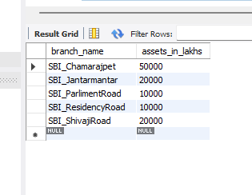

**Find all the customers who have at least two accounts at the same branch (ex.  
SBI_ResidencyRoad)**

select customer_name from depositer d,bankaccount b where d.accno = b.accno and branch_name ='SBI_ResidencyRoad' having count(customer_name)>=2;

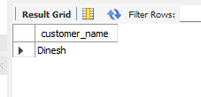

select customer_name,count(*),branch_name from depositer d inner join bankaccount b on d.accno group by customer_name having count(*)>=2

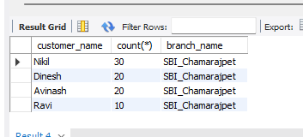

**CREATE A VIEW WHICH GIVES EACH BRANCH THE SUM OF THE  
AMOUNT OF ALL THE LOANS AT THE BRANCH**

create view sum_ as

select branch_name,sum(amount)

from loan

group by branch_name;

select* from sum_

